**Secrets in K8s**

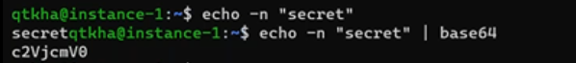

* We can create secret imperatively kubectl create secret and we have the following options
  + generic
  + docker-registry
  + tls
* Official docs: https://kubernetes.io/docs/concepts/configuration/secret/
* Consuming secret as Environmental variable

Refer below for the changes

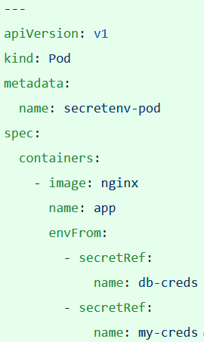

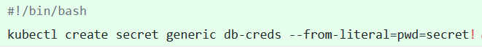

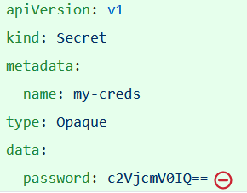

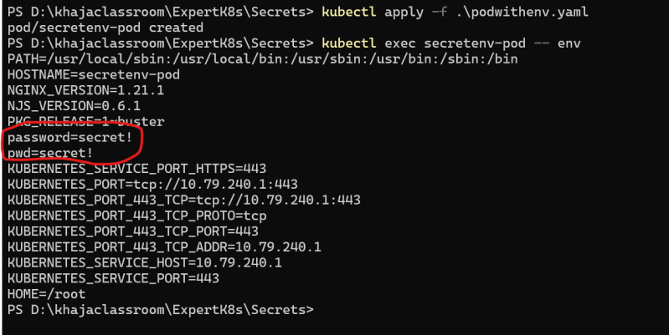

Mounting Secret as a Volume >> for changeset refer below

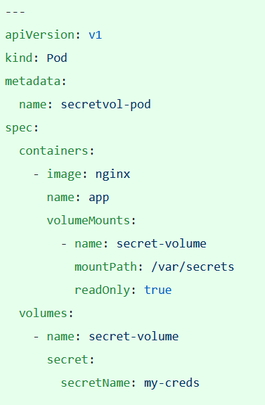

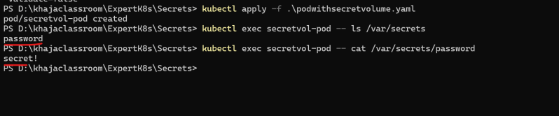

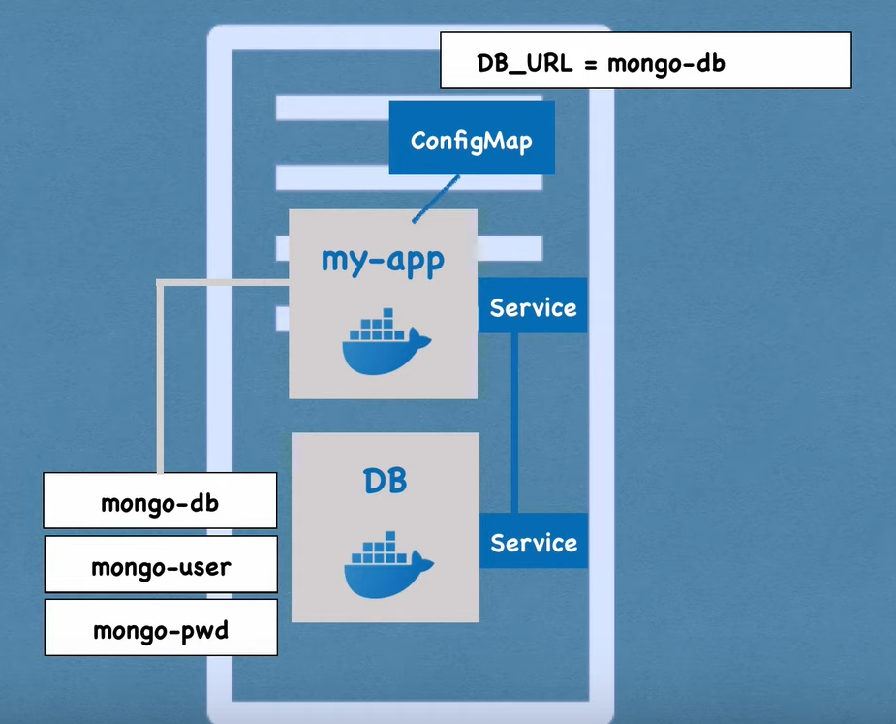

A ConfigMap is an API object used to store non-confidential data in key-value pairs. [Pods](https://kubernetes.io/docs/concepts/workloads/pods/) can consume ConfigMaps as environment variables, command-line arguments, or as configuration files in a [volume](https://kubernetes.io/docs/concepts/storage/volumes/).

A Secret is an object that contains a small amount of sensitive data such as a password, a token, or a key. Such information might otherwise be put in a [Pod](https://kubernetes.io/docs/concepts/workloads/pods/) specification or in a [container image](https://kubernetes.io/docs/reference/glossary/?all=true#term-image). Using a Secret means that you don't need to include confidential data in your application code.

**Secrets are similar to** [**ConfigMaps**](https://kubernetes.io/docs/concepts/configuration/configmap/) **but are specifically intended to hold confidential data.**